IMPORTANT SAFETY NOTICE
For Home Owners and Building Owners
Central Sprinkler Recalls 35 Million O-Ring Fire Sprinklers

In July 2001 Central Sprinkler Company, an affiliate of TYCO Fire Products LP of Lansdale, PA in cooperation with the Unites States Consumer Product Safety Commission (CPSC) announced a recall to replace 65 different models of Central type sprinkler heads – using O-Ring type water seals – totaling approximately 35 million Central fire sprinklers.

Under certain circumstances, especially with lower water pressures common in such occupancies as Hotel/Motel, Apartments, and Single Family Homes, these sprinklers may fail to activate during a fire.

These O-Ring model sprinklers were installed in a wide variety of buildings including homes, apartments, hospitals, day care facilities, schools, dormitories, nursing homes, supermarkets, hotels, parking garages, warehouses, and office buildings. In addition, they may be concealed – by design – with a ceiling plate to appear more aesthetically pleasing.
Belleville Bottom View

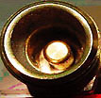

Shaped like a cone? Leave it alone.
O-Ring
Bottom View

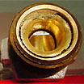

Flat Face?
Better Replace!
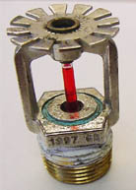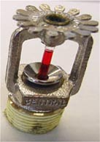
O-Ring exterior
Recalled
Belleville exterior
Not Recalled

Central will provide – free of charge – replacement sprinkler heads using the Belleville Spring water seal and will also pay for the involved labor. This five to seven year program currently has a two to three year waiting period after your claim is filed and accepted.

For Help In Identifying Your Sprinklers:

If you require any assistance in identifying the recalled heads, filling out the claim forms, or submitting your claim with TYCO, please contact the Washington State Fire Marshal’s Office toll free at (866) WSP-SFMO--
(866-977-7366). The Office of the State Fire Marshal is committed to making this recall work and will help you identify these heads and offer whatever assistance you need. You may also obtain your complete notice packet by calling 1-800-871-3492 or visit www.sprinklerreplacement.com.

Why Wait? – Don’t Tempt Fate

